Task 2: Create a Spring Boot application where one component depends on another using @Autowired at field level through
field injection. Create controller and service class. Call the service methods using REST endpoints.
Step 1: Create Spring Boot Project in Eclipse
Method (Using Spring Initializr inside Eclipse)
- Open Eclipse
- Click File → New → Spring Starter Project
- Project Name: FieldInjectionDemo
- Packaging: Jar
- Java Version: 17 (or your installed version)
Add Dependencies: Spring Web
- Click Finish

Step 2: Create Service Class
- Create package:
- Right click on com.example.demo
→ New → Package
Name: com.example.demo.service
- 📄 Create Class:
- Right click on service
→ New → Class
Name: MyService
package com.example.demo.service;
import org.springframework.stereotype.Service;
@Service
public class MyService {
public String getMessage() {
return "Hello from Service Layer!";
}
public int addNumbers(int a, int b) {
return a + b;
}
}
Step 3: Create Controller Class
Create package:
Right click on com.example.demo
→ New → Package
Name: com.example.demo.controller
Create Class:
Right click on controller
→ New → Class
Name: MyController
package com.example.demo.controller;
import org.springframework.beans.factory.annotation.Autowired;
import org.springframework.web.bind.annotation.*;
import com.example.demo.service.MyService;
@RestController
@RequestMapping("/api")
public class MyController {
@Autowired
private MyService myService;
@GetMapping("/message")
public String getMessage() {
return myService.getMessage();
}
@GetMapping("/add")
public int add(@RequestParam int a, @RequestParam int b) {
return myService.addNumbers(a, b);
}
}
Step 4: Main Application Class
package com.example.demo;
import org.springframework.boot.SpringApplication;
import org.springframework.boot.autoconfigure.SpringBootApplication;
@SpringBootApplication
public class FieldInjectionDemoApplication {
public static void main(String[] args) {
SpringApplication.run(FieldInjectionDemoApplication.class, args);
}
}
Step 5: Run the Application
- Right click on FieldInjectionDemoApplication.java
- Click Run As → Spring Boot App
Tomcat started on port(s): 8080
Started FieldInjectionDemoApplication
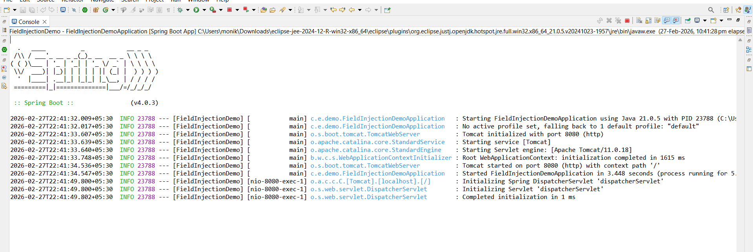
Step 6: Test REST Endpoints
Test Message API
http://localhost:8080/api/message
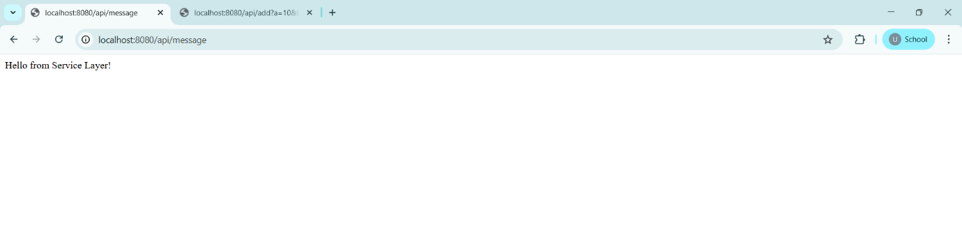

Test Add API
http://localhost:8080/api/add?a=10&b=20
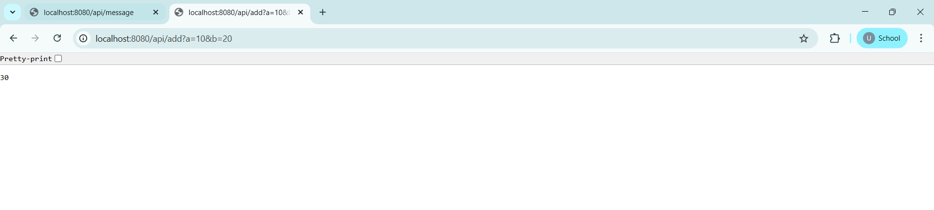
Project Structure Image:
